|  |  |
| --- | --- |
| **YEAR 8** | **Sound Energy** |

|  |  |
| --- | --- |
| **Learning Intentions** | **Success Criteria** |
| Understand sound energy. | * Describe sound energy. * Provide examples of sources of sound. * Explore how different sounds are made. |

**READ:** *Sound Energy*

**Sound is energy** that travels as a result of **vibration**. Sound **needs matter to exist**. The **energy** is transferred through a substance (such as air) in a wave. This means there is generally no sound in space. Space is a vacuum; there are no particles to vibrate and so even if you scream or crash your rocket, there will only be silence. Only, when the sound waves reach the **ear** they can be heard.

|  |  |
| --- | --- |
| Sound | Vibrating source |
| Speech | Vocal cords (flaps of skin) |
| Drum | Skin on the drum |
| Piano | String inside the piano |
| Saxophone | Reed in the mouth piece |
| Car stereo | Cardboard cone in the speaker |
| Ringing bell | Metal that the bell is made from |

**Different Sounds**

**Frequency, pitch & volume** describes the different types of sounds we hear.

* **Volume** is the measure of loudness. To measure volume we use decibels (db).
* **Frequency:** the number of soundwave cycles that occur in one second. The unit of frequency measurement is Hertz (Hz).
* **Pitch** the way we hear frequency. It is measured in hertz (Hz).

**WATCH:** *What is Sound?*

|  |  |
| --- | --- |
| File:Logo of YouTube (2015-2017).svg - Wikipedia | Watch this YouTube video:  <https://www.youtube.com/watch?v=gdGyvGPZ1G0> |

**ACTIVITY 1:** *Making Music*

**YOUR TASK:** Create music using items from the science classroom or your home.

1. Create three different sounds:
   1. High pitch sound

**SAFETY:** Be careful not to break any items while experimenting!

* 1. Medium pitch sound
  2. Low pitch sound

1. CHALLENGE: Can you play a song using items from the science lab?   
   Try Hot Cross Buns.   
     
   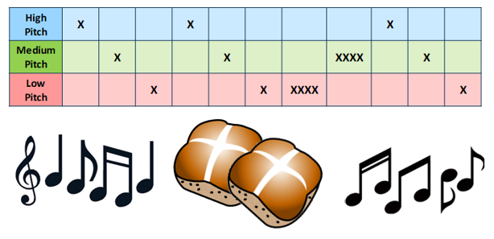

**ACTIVITY 2:** *Sound on Scholastic*

<https://yespress.info/new-cliparts/hot-cross-bun-clipart.htm>

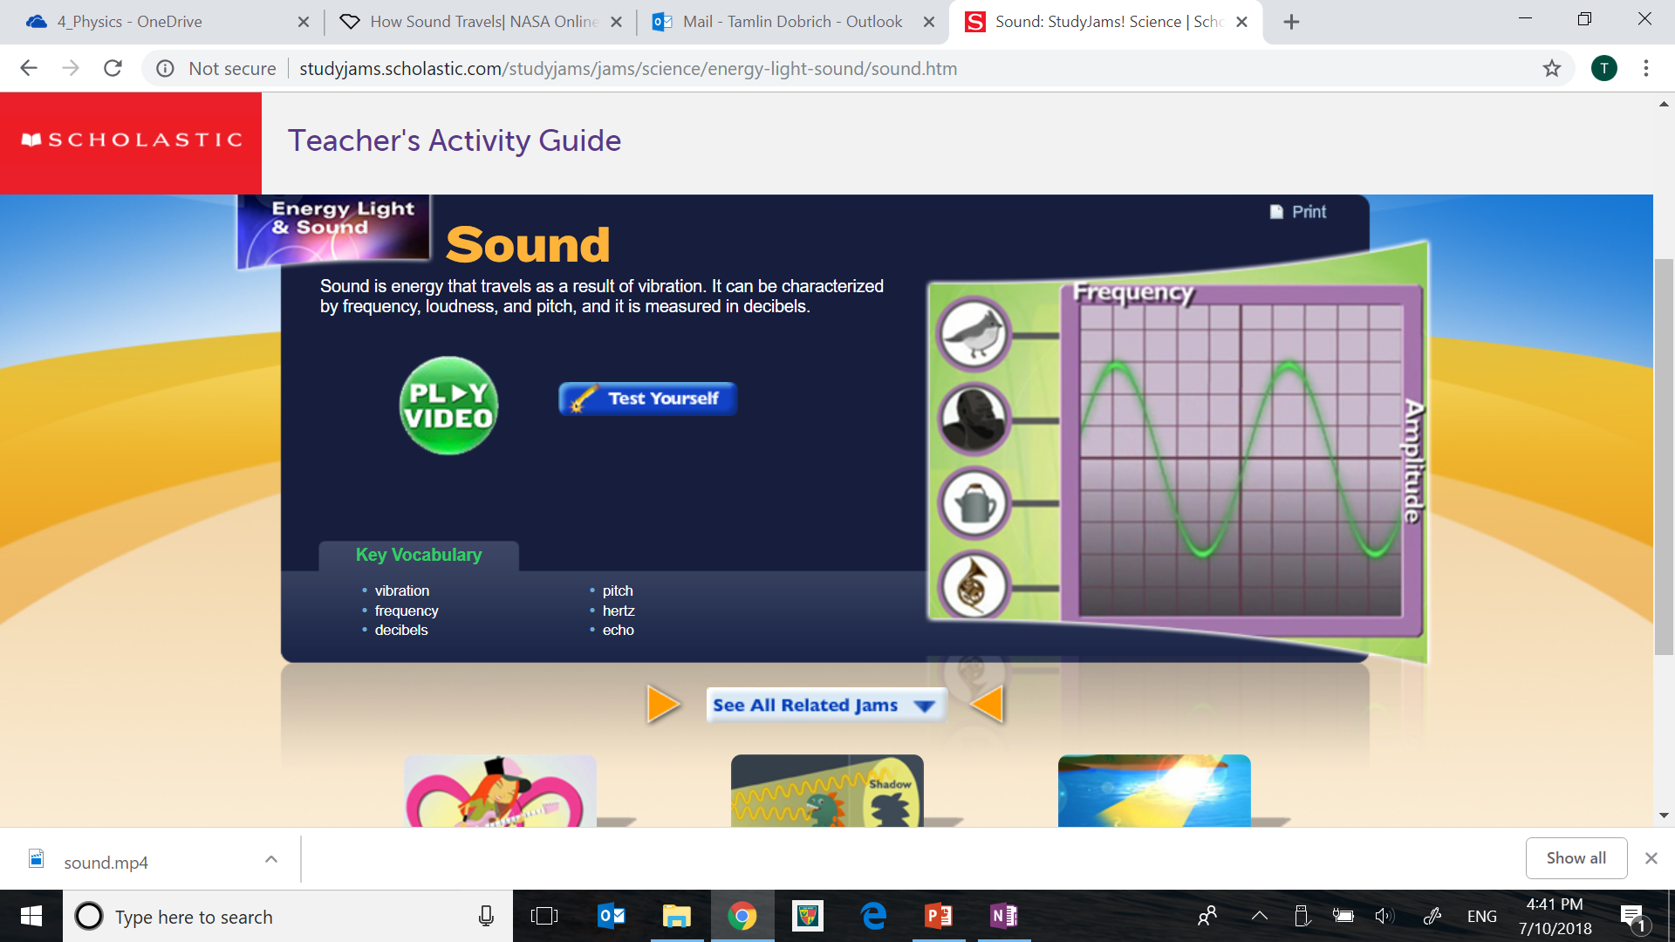

**Image:** <http://studyjams.scholastic.com/studyjams/jams/science/energy-light-sound/sound.htm>

**YOUR TASK:**

1. GO TO: <http://studyjams.scholastic.com/studyjams/jams/science/energy-light-sound/sound.htm>
2. Watch the video about sound from “Scholastic Study Jams”
3. Complete the “Test Yourself” activity provided.

**ACTIVITY 3:** *Making Instruments   
(Science as a Human Endeavour)*

Sound is a type of energy that helps create music through vibrations. Churchlands is a Gifted and Talented music school… so let’s make some music while learning about the physics of sound.

**Your Task:**

1. 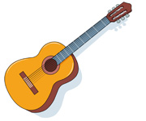Construct an instrument capable of making sound that also allows you to change the pitch.
2. Explain how your instrument produces these different sounds.

**Submission Details:**

* One homemade musical instrument that also allows   
  you to change the pitch.
* One page explanation describing how your instrument produces these different sounds.
* Be creative – there will be a prize for the best instrument produced.

<https://classroomclipart.com>

**Your task in detail:**

A guide of how marks can be achieved for this assessment are shown below.

|  |  |  |  |  |  |  |
| --- | --- | --- | --- | --- | --- | --- |
|  | **0**  *not achieved* | **1**  *needs assistance* | **2**  *achieved* | **3**  achieved | **4**  above average | **5**  outstanding |
| **INSTRUMENT** | Musical instrument not complete. | Musical instrument created. Poor design/construction. Little effort made. | Musical instrument has basic/generic design and range of pitch in limited (below five). | Musical instrument has basic/generic design but range of pitch is extensive (greater than five). | Musical instrument has unique/complex design and an extensive range of pitch (greater than five). | Musical instrument has unique/complex design and an extensive range of pitch (greater than five). Additional structures/features included or great detail. |
| **EXPLAINATION** | Explanation about how instrument produces different sounds not complete. | Explanation about how instrument produces different sounds is described in limited detail or has multiple errors. | Explanation about how instrument produces different sounds is described in basic detail or has few errors. | Explanation about how instrument produces different sounds is described in limited detail or has multiple errors. | Explanation about how instrument produces different sounds is described in great detail. No errors. | Explanation about how instrument produces different sounds is described in great detail. Provides additional relative information.  No errors. |

**SCORE: ______ /10**

**END OF WEEK TEST:** *Sound**Energy*  
 **Question 1**

In your own words, describe sound energy.

|  |
| --- |
|  |

**Question 2**List five examples of sound energy.

|  |  |
| --- | --- |
| **1** |  |
| **2** |  |
| **3** |  |
| **4** |  |
| **5** |  |

**Question 3**Identify whether the following examples of heat energy would be useful or not useful.

|  |  |
| --- | --- |
| **Example:** | **Useful or Not Useful?** |
| **A light bulb feels hot to touch.** |  |
| **Heat produced from the breaks of a bike.** |  |
| **An incubating lamp for baby chickens.** |  |
| **Friction from rubbing sticks to light a fire.** |  |
| **A spaceships burns up as it reenters the atmosphere.** |  |
| **Clothes are hung to dry on a sunny day.** |  |

Rate your understanding of heat (thermal) energy:  
 